**Physics Manual**

**B.Sc. [Semester-1]**

**Physics Practical**

**Subject Code: US01CPHY22**

## **Class:** FYBSc Sem 1 **Subject:** Physics

## ***Name:_________________________________***

## **Roll No**.________ **Division** _____



## **Physics Department**

## **V.P. & R. P. T. P Science College**

**Vallabh Vidyanagar - 388 120**

# **[Managed by Charutar Vidya Mandal]**

**Website:** [**www.vpscience.org**](http://www.vpscience.org)

**I N D E X**

|  |  |  |  |  |
| --- | --- | --- | --- | --- |
| **Sr. No** | **Name of the Experiment** | **Page No.** | **Date of Experiment** | **Signature** |
| 1 | Full Wave Rectifier  [AC Component] |  |  |  |
| 2 | Zener Diode Characteristics |  |  |  |
| 3 | Frequency of AC by Sonometer |  |  |  |
| 4 | Forward Biased PN Junction Diode |  |  |  |
| 5 | Torsional Pendulum |  |  |  |
| 6 | ‘η’ by Statical Method |  |  |  |
| 7 | Poisson’s Ratio for rubber |  |  |  |
| 8 | ‘Y’ by Cantilever |  |  |  |
| 9 | Least Square Fitting Method |  |  |  |
|  | Viva-Voce |  |  |  |

**Experiment No 1 Date ­­­­_____________**

**Full Wave Rectifier [AC Component]**

**Aim:** To study the full-wave rectifier circuit.

**Apparatus:** Step-down Transformer (0-24V), AC Voltmeter (0-25V),

PN junction Diodes, Load Resistance, Capacitor

**Circuit Diagram:**

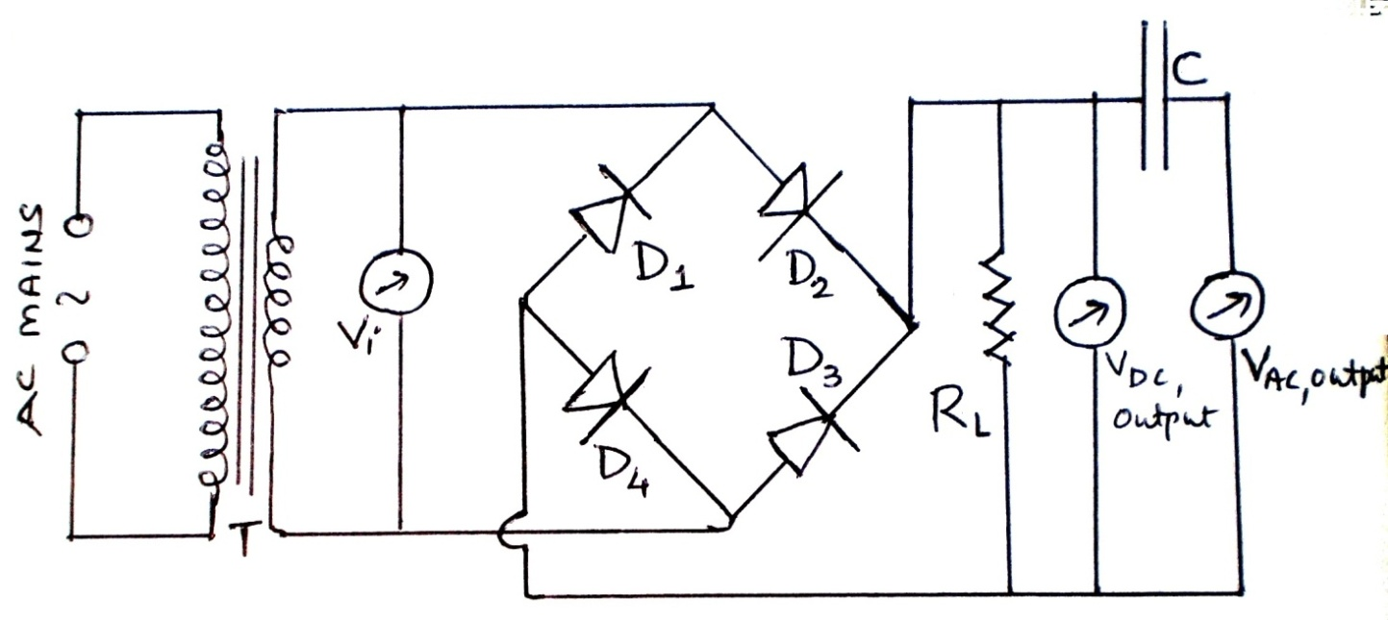

**Here**

**T** → Step-down Transformer (0-24V)

**VDC** → DC Voltmeter (0-15V),

**VAC** → AC Voltmeters (0-25V) and (0-15 V)

**C** → Capacitor

**RL** → Load Resistance

**D1, D2, D3 andD4** → PN junction Diodes

**Procedure:**

1. Connect the circuit as shown in the circuit diagram.
2. Now switch on the power supply. Select the value of the AC input voltage, using the given transformer and measure it [**Vi**]. Note the corresponding AC output voltage [**VAC, output**] and DC output voltage [**VDC, output**].
3. Now change the value of the AC input voltage and measure it. Also, note the corresponding output AC and DC voltages.
4. Repeat the experiment for six different values of input AC voltage.
5. Find out the ripple factor [****] of the circuit and calculate theoretical DC voltage [**VDC**] using given formula and verify the formula.

**Observation Table:**

|  |  |  |  |  |  |
| --- | --- | --- | --- | --- | --- |
| **Obs. No.** | **Input AC voltage**  **Vi volt** | **Output DC voltage VDC, output volt** | **Output AC voltage VAC, output volt** | **Ripple factor** | **Theoretical**  **Output DC voltage**    **Volt** |
| 1 |  |  |  |  |  |
| 2 |  |  |  |  |  |
| 3 |  |  |  |  |  |
| 4 |  |  |  |  |  |
| 5 |  |  |  |  |  |
| 6 |  |  |  |  |  |
| 7 |  |  |  |  |  |

**From Table:** MeanRipple factor ()=_____________________

**Calculation: [For at least one reading]**

**[1]** 

**[2]** Theoretically the output DC voltage

 =______________ volt

**Graph:** Plot a graph of VAC, output against VDC, output and also calculate ripple factor.

**Results:**

**[1]** The values of ripple factor [] obtained in the experiment are as under:

|  |  |  |
| --- | --- | --- |
| Method | Using formula | Using graph |
| Experimental |  |  |
| Theoretical | **0.48** | |

**[2]** From the observation table, we can conclude that the theoretically DC output voltage is nearly equal to measured DC output voltage and hence given theoretical formula for output DC voltage is verified.

**Teacher’s Signature**

**Experiment No 2 Date ­­­­_____________**

**Zener Diode Characteristics**

**Aim:** To study the characteristic of a Zener Diode.

**Apparatus:** Power Supply, Experimental Circuit Board, Voltmeter, Ammeter

**Circuit Diagram:**

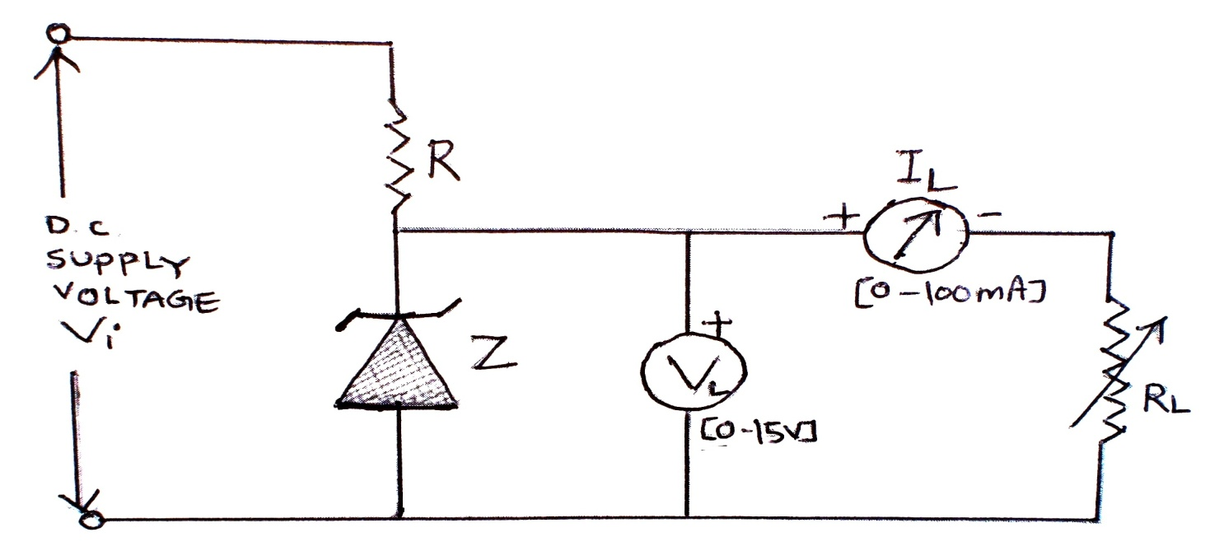

**Here,**

**Vi → Input DC Supply Voltage Z → Zener Diode**

**R → Resistor**

**VL → DC Voltmeter (0-15 V)**

**RL → Potentiometer**

**IL → DC Milliammeter (0-100mA)**

**Procedure:**

1. Setup the circuit as shown in the figure.
2. Take a suitable value of supply voltage. (Vi = 8V) Adjust load current IL to a fixed value (IL = 10 mA). Measure the load voltage VL.
3. Now adjust load current IL to 20 mA and 30 mA for the same value of supply voltage i.e. Vi = 8V and measure corresponding load voltage VL.
4. Increase input voltage in small steps of 2V. Measure voltage across the load in each case for the different fixed load current.
5. Plot VL versus Vi­ for all three values of IL. Find the minimum values of Vi for which VL becomes almost constant.

**Observations Table:**

|  |  |  |  |  |
| --- | --- | --- | --- | --- |
| Obs. No. | Input Voltage  Vi volt | Voltage across load VL  volt | | |
| IL = 10 mA | IL = 20 mA | IL = 30 mA |
| 1 |  |  |  |  |
| 2 |  |  |  |  |
| 3 |  |  |  |  |
| 4 |  |  |  |  |
| 5 |  |  |  |  |
| 6 |  |  |  |  |
| 7 |  |  |  |  |
| 8 |  |  |  |  |
| 9 |  |  |  |  |
| 10 |  |  |  |  |
| 11 |  |  |  |  |
| 12 |  |  |  |  |

**Graph:** Plot VL (in volt) versus Vi­ (in volt) for all three values of IL (in mA).

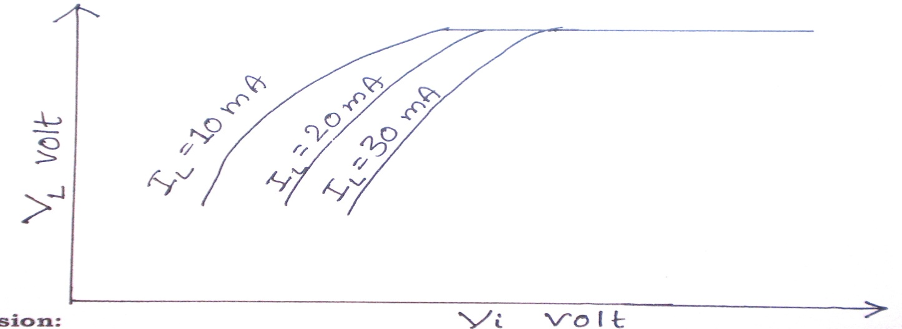

**Conclusion:** From the graph, we can conclude that the Zener diode can be used to regulate the output voltage.

**Teacher’s Signature**

**Experiment No 3 Date ­­­­_____________**

**Frequency of AC by Sonometer**

**Aim:** To determine the frequency of AC by sonometer.

**Apparatus:** Sonometer, Step-down Transformer, Two Bar Magnets etc.

**Procedure:**

1. Connect the secondary of the step-down transformer through a sonometer wire.
2. Place the magnets below the wire and its one pole towards it.
3. Start the current in the circuit by applying certain tension T.
4. Adjust the length of the sonometer wire by adjusting the movable bridge so that wire starts vibrating, measure [L1]. The wire should vibrate forming one good loop which can see very easily.
5. Measure the length of the wire between the bridges. Repeat again two more times and find the mean of the three lengths.
6. Repeat the experiment for different tension and find the corresponding resonating lengths.

|  |
| --- |
| **For your Practice**  **FREQUENCY OF A.C. BY SONOMETER**  Connect step-down transformer with Sonometer wire and pass current through it. Place magnets at the center of the Sonometer wire. Apply different tension (T) and measure the length (L) of wire for one steady loop. Plot the graph of $T→L^{2}$ and calculate the frequency of A.C. signal (N) using equation    Where m = mass of wire per unit length = ______________ gm/cm. |

**Observations:**

[1] Mass per unit length of wire [**m**]= 0.0155 gm/cm

[2] Mass of pan [**m0**]= _____________ gm

**Observation Table:**

|  |  |  |  |  |  |  |  |  |
| --- | --- | --- | --- | --- | --- | --- | --- | --- |
| Obs.  No. | Mass in pan  m1  gm | Total Mass  on the hanger  M=m0+m1  Gm | Tension  in wire  T=Mg  dyne | Resonating Length of the wire | | | Mean Length  L cm | Frequency  of AC  Hz |
| L1 cm  00000 | L2 cm | L3 cm |
| 1 | 100 |  |  |  |  |  |  |  |
| 2 | 200 |  |  |  |  |  |  |  |
| 3 | 300 |  |  |  |  |  |  |  |
| 4 | 400 |  |  |  |  |  |  |  |
| 5 | 500 |  |  |  |  |  |  |  |
| 6 | 600 |  |  |  |  |  |  |  |

**Calculation:** [Show calculation only for one reading]

T = Mg =______________________________dyne



**Result:** Frequency of AC =_____________Hz.

**Teacher’s Signature**

**Experiment No 4 Date ­­­­_____________**

**Characteristics of Forward Biased PN - Junction Diode**

**Aim**: To draw forward-biased characteristic curves of Si and Ge semiconducting diodes and to determine its forward resistance.

**Apparatus:** Circuit Board, Power Supply (0-15 volt),

DC-Voltmeter (0-1 volt) Milliammeter (0-50 mA)

**Circuit Diagram:**

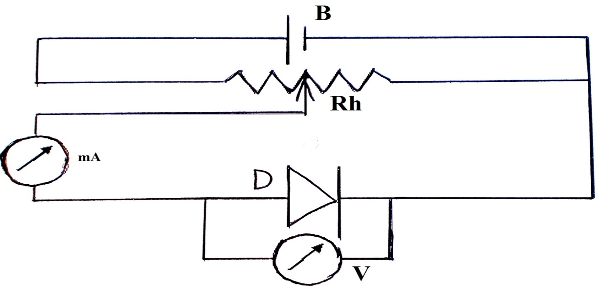

**Here**

**B** → Battery Eliminator **Rh →** Potentiometer

**D** **→** PN Junction Diode **V →** Voltmeter (0 -1 V)

**mA** **→** Milliammeter (0-50 mA)

**Procedure:**

1. The connections are made as shown in the circuit diagram. In this experiment connect Si diode parallel to the voltmeter.
2. Switch on the power supply.
3. With the help of the potentiometer increase the voltage slowly.
4. Note down the milliammeter and voltmeter readings. Tabulate your observations.
5. Now connect Ge diode and repeat the experiment.
6. Draw graphs between forward voltage [**VF]** and forward current **[IF]** separately for both the diodes and find out the slope of each graph.

**Observation Table -1: [For Si Diode]**

|  |  |  |
| --- | --- | --- |
| **Sr. No.** | **Forward Voltage [VF]**  **in volt** | **Forward Current [IF]**  **in mA** |
| 1 |  |  |
| 2 |  |  |
| 3 |  |  |
| 4 |  |  |
| 5 |  |  |
| 6 |  |  |
| 7 |  |  |
| 8 |  |  |

**Observation Table -2: [For Ge Diode]**

|  |  |  |
| --- | --- | --- |
| **Sr. No.** | **Forward Voltage [VF]**  **in volt** | **Forward Current [IF]**  **in mA** |
| 1 |  |  |
| 2 |  |  |
| 3 |  |  |
| 4 |  |  |
| 5 |  |  |
| 6 |  |  |
| 7 |  |  |
| 8 |  |  |

**Graph:**

|  |
| --- |
| **untitled.bmp**  A  C  B |

**Calculations of Forward Resistance:**

**From Graph-1 : [For Si Diode]**

Slope = $\frac{AB}{BC}$ =-------- [**rd**] = = _________Ω

**From Graph-2 : [For Ge Diode]**

Slope = $\frac{AB}{BC}$ =-------- [**rd**] = = _________Ω

**Results:**

**[1]** The V-I characteristic of the forward-biased diode is as shown in the graph.

**[2]** The forward resistance of the given Si diode is _________Ω and ________________Ω for Ge diode.

**Teacher’s Signature**

**Experiment No 5 Date ­­­­_____________**

**Torsional Pendulum**

**Aim:**  To determine

1. restoring couple per unit twist in a wire and
2. Moment of Inertia of the irregular ring using given Torsional Pendulum.

**Apparatus:** Disc, Regular Ring, Irregular Ring, Stop Watch, etc.

**Procedure:**

1. First of all, oscillate the disc horizontally. The amplitude of oscillation should be small.
2. Measure accurately the time for 10 oscillations thrice. Find mean time T and hence periodic Time [**T1**].
3. Now oscillate disc and regular disc simultaneously and find out the periodic time of such a system [**T2**].
4. Finally, suspend the irregular ring and the disc simultaneously and find out the periodic time of such a system [**T3**].
5. Calculate the restoring couple per unit twist and moment of inertia of the irregular ring using given relations.

**Observations:**

**[1]** Moment of Inertia of the given disc = [**Id**] = _______­­­­­­­­­_____________gm cm2

**[2]** Moment of Inertia of the given regular ring = [**Ir**] =______________gm cm2

**Observations Table:**

|  |  |  |  |  |  |  |  |
| --- | --- | --- | --- | --- | --- | --- | --- |
| **Obs.**  **No.** | **Suspended**  **Body** | **Time for 10**  **Oscillations in sec.** | | | **Mean**  **time**  **t sec.** | **Periodic Time**  **T = t/10 sec** | **T2**  **sec2** |
| t1 | t2 | t3 |
| 1 | Disc |  |  |  |  | **T1** |  |
| 2 | Disc+  Regular  Ring |  |  |  |  | **T2** |  |
| 3 | Disc+  Irregular  Ring |  |  |  |  | **T3** |  |

**Calculations:**

**[1]** The restoring couple per unit twist

$C_{1} = \frac{4 π^{2} I_{d}}{T_{1}^{2}}=________________________=___________________________________$ dyne-cm

${C_{2} = \frac{4 π^{2} ( {I_{d} +}_{ }I_{r})}{T_{2}^{2}}=______________________=___________________________}_{}$ dyne-cm

Mean value of the restoring couple per unit twist

${C_{} = \frac{\left( C_{1}+C_{2}\right)}{2}____________________}_{}$ =___________________dyne cm

**[2]** Calculated Moment of Inertia of the given Disc

gm cm2

**[3]** Moment of Inertia of the given Irregular Disc

[Take given value of Id ]

gm cm2

**Results:**

**[1]** Restoring Couple per unit twist [C] = ___________________dyne cm

**[2]** Moment of Inertia of the given Irregular Ring

[]=____________________________gm cm2

**Teacher’s Signature**

**Experiment No 6 Date ­­­­_____________**

**'η' by Statical Method**

**Aim:** To determine the coefficient of the rigidity of the material of the given rod.

**Apparatus:** Statical Apparatus, Micrometer Screw, Weights, Thread, Meter scale.

**Experimental Setup:**

**Procedure:**

1. In this apparatus, the rod whose modulus of rigidity is to be measured is kept horizontal one end of the rod is fixed and the wheel or pulley is attached to the other end of the rod. A pointer with a circular scale measures an angle or twist in degree. The pointer can slide on the rod.
2. A force is applied at the outer edge or wheel it produces a couple called applied couple. The rod is twisted under the action of this applied couple. Generally, a force is produced by suspending mass so here the mass is suspended at the edge of the wheel on the hook. This is taken as zero mass. (Dead mass & the pointer is adjusted on zero of circular scale.
3. A suitable mass is placed on hook and the reading of pointer is noted. This measures an angle of twist in degree.
4. Increase the step by step and the corresponding angle of twist is noted. (Loading)
5. In the next step, the mass is decreased step by step and the corresponding angle of twist is also noted (unloading). The mean value of the angle of twist is considered for calculation.
6. In the twisted position of the rod, the restoring couple is equal to the applied couple. The restoring couple = Cθ, where C is the restoring couple per unit twist.

**Observations:**

$$LC of Micrometer Scerw= \frac{Pitch (p)}{Total nos of divisions on head scale}=\frac{0.1 cm}{100}=0.001 cm$$

Zero error = ± ______________________cm

**Diameter of the given rod using a micrometer screw**

(i) _____________cm (ii) _____________ cm (iii) _____________ cm

Mean diameter [**d’**] = _____________cm

Mean corrected diameter [d] = d’ $∓$ Zero error = _____________cm

Radius of the rod = r = d/2 = _____________cm

Circumference of the wheel or pulley [S]= _____________cm

Diameter of the wheel or pulley = D = S/π =_____________cm

**Observation Table-1:**

|  |  |  |  |  |  |  |  |
| --- | --- | --- | --- | --- | --- | --- | --- |
| **Sr**  **No** | **Length**  **of**  **the rod**  **from**  **fixed**  **end** | **Applied mass**  **M**  **Gm** | **Reading of the pointer in degree** | | **Mean angle $=\frac{[a+b]}{2}$**  **in degree** | **Angle of twist for 500 gm in degree** | **Mean**  **angle of twist**  **for**  **500 gm** |
| **loading [a]** | **unloading**  **[b]** |
| 1 | *l1*  =______cm |  |  |  |  |  | 1  =_______ |
| 2 |  |  |  |  |  |
| 3 |  |  |  |  |  |
| 4 |  |  |  |  |  |
| 5 |  |  |  |  |  |
| 6 |  |  |  |  |  |

**Calculation-1:**



=_________________________________ dyne/cm2

**Observation Table-2:**

|  |  |  |  |  |  |  |  |
| --- | --- | --- | --- | --- | --- | --- | --- |
| **Sr**  **No** | **Length**  **of**  **the rod**  **from**  **fixed**  **end** | **Applied mass**  **M**  **Gm** | **Reading of the pointer in degree** | | **Mean angle $=\frac{[a+b]}{2}$**  **in degree** | **Angle of twist for 500 gm in degree** | **Mean**  **angle of twist**  **for**  **500 gm** |
| **loading [a]** | **unloading**  **[b]** |
| 1 | *l2*  =______cm |  |  |  |  |  | **2**  **=_______** |
| 2 |  |  |  |  |  |
| 3 |  |  |  |  |  |
| 4 |  |  |  |  |  |
| 5 |  |  |  |  |  |
| 6 |  |  |  |  |  |

**Calculation-2:**



=_________________________________ dyne/cm2

**Calculation-3: [If *l2* is greater than *l1*]**



=_________________________________ dyne/cm2

FindMean  =

**Result:** The coefficient of rigidity of the material of the given rod [] is found to be _____________________________________ dyne/cm2.

**Teacher’s Signature**

**Experiment No 7 Date ­­­­_____________**

**Poisson’s Ratio for Rubber**

**Aim:** To determine the Poisson’s Ratio for Rubber for a given rubber tube.

**Apparatus:** About One Meter Long Rubber Tube, Burette, Weight, Scale,

Pan, Vernier Calipers

**Procedure:**

* 1. Suspend vertically a hollow rubber tube having a burette fitted at the upper end from a rigid support. Here the cycle tube is used.
  2. Fill the tube along with the burette with water so as to have water level upto the middle of the burette. Attach a pan with pointer arrangement at the lower end of the rubber tube.
  3. The pointer can move over a vertical scale. See that there is no air bubble in the tube.
  4. Measure the diameter of the rubber tube at various points along its length with the help of vernier calipers.
  5. Keep different weights in the pan increasing in the steps of 100 gm or 200 gm. Note the position of the pointer on the scale and the level of water in the burette.
  6. Similarly, take the readings of the pointer and the level of water in the burette for unloading in the same step.
  7. The reading of the water level in the burette gives the volume V. The position of pointer on the scale gives the length L for the tube.
  8. The reading of the pointer and that of the water level in burette should be noted accurately. The tube should not be disturbed while loading and unloading the pan. Tabulate your observation in the tabular form.

**Observation:**





**Diameter of the given Tube**

(i) ______________cm (ii)_______________cm (iii)_____________cm

Mean D __________________ cm

[2] Radius of the tube [R] = $\frac{D}{2}$ = ________________ cm

[3] Area of cross section of the tube = [**A**]=

[**A**]= _____________________cm2

**Observation Table:**

|  |  |  |  |  |  |  |  |
| --- | --- | --- | --- | --- | --- | --- | --- |
| **Obs.**  **No.** | **Weight**  **in Pan**  **gm** | **Reading of the burette** | | | **Reading on the Scale** | | |
| **V1**  **cm3** | **V2**  **cm3** | **mean V**    **cm3** | **L1**  **cm** | **L2**  **Cm** | **mean**  **cm** |
| 1 |  |  |  |  |  |  |  |
| 2 |  |  |  |  |  |  |  |
| 3 |  |  |  |  |  |  |  |
| 4 |  |  |  |  |  |  |  |
| 5 |  |  |  |  |  |  |  |
| 6 |  |  |  |  |  |  |  |

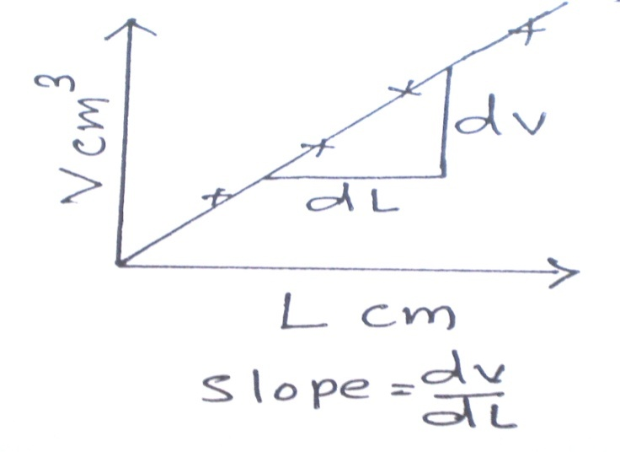**Graph:**

Plot a graph of V against L. The graph will be a straight line. Find the slope (dV/dL) of the graph.

**Calculation:**

|  |  |
| --- | --- |
| Poisson’s ratio |  |

**Result:** The Poisson’s Ratio for Rubber of a given rubber tube is____________.

**Teacher’s Signature**

**Experiment No 8 Date ­­­­_____________**

**‘Y’ by Cantilever**

**Aim:** To determine Young Modulus of a beam of a rectangular bar in the form of cantilever.

**Apparatus:** Rectangular Bar Strip, C-clamp, Weight Box, Pointer, Meter Scale, Vernier Calipers, Micrometer Screw, Stand

**Procedure:**

1. Measure the length of a beam [**L**] forming a cantilever between the point of support and the end of a beam.
2. Measure breadth of the given beam [**b**] by means of vernier calipers and thickness of the beam [**d**] by means of micrometer screw.
3. The beam is rigidly fixed at one end by means of C-clamp. The other end is loaded with different masses. First observation for zero mass should be taken without hanger. Second observation for 50 gm should be taken with only hanger.
4. The depression is measured directly by means of pointer attached at the end of a beam on the scale placed beside the pointer.
5. The readings on the scale are noted while loading and unloading find the depression [**e’**] for different masses.
6. Draw a graph of masses [**M**] against depression [**e'**]. Find slope of the graph and hence calculate the young modulus [**Y**].

**Observation:**





**Breadth of the given beam using Vernier Calipers’:**

(1) ______________cm (2) ______________ cm (3) _______________ cm

Mean breadth [b]= _______________ cm



Zero error = ± _______________ cm

**Thickness of beam using micrometer screw**

(i) ______________ cm (ii) ______________ cm (iii) ______________ cm

Mean thickness [**d’**] = _______________ cm

Mean corrected thickness [d] = d’ $∓$ Zero error = _______________ cm

**[C]** Measure the length of given cantilever [**L**] = _______________ cm

**Observation Table:**

|  |  |  |  |  |  |  |
| --- | --- | --- | --- | --- | --- | --- |
| **Obs. No.** | **Load**  **M gm** | **Reading of the pointer on the scale while** | | $$Mean= \frac{x+y}{2}$$**cm** | **Depression for same load**  **[e]**  **cm** | **Depression**  **for different loads**  **e’ cm** |
| Loading  cm ‘x’ | Unloading  cm ‘y’ |
| 1 | 0 |  |  | a | - | - |
| 2 | 50 |  |  | b | a~b | a~b |
| 3 | 100 |  |  | c | b~c | a~c |
| 4 | 150 |  |  | d | c~d | a~d |
| 5 | 200 |  |  | e | d~e | a~e |
| 6 | 250 |  |  | f | e~f | a~f |
| 7 | 300 |  |  | g | f~g | a~g |
|  |  |  |  | Mean emean |  |  |

**Calculations:**

**[1] Numerical Method [From Table mean e _________________cm]**

[From Table,   = _____________ gm/cm]



= _______________________________dyne/cm2

**[2] Graphical Method**

[Draw a graph of M e’ and find slope of the graph.

From Graph, Slope = m/e’ = __________________________ gm/cm



= _______________________________dyne/cm2

**Results:**

In this experiment, Young Modulus of the given material [Y] of the given rectangular bar is equal to ___________________dyne/cm2 [From Numerical Method] and _____________________ dyne/cm2 [From graphical method].

**Teacher’s Signature**

**Experiment No 9 Date ­­­­_____________**

**Linear Least Square Fitting Method**

**Aim:** To determine slope and intercept on y-axis of the given linear data

using the least square fitting method.

**Theory:** The least square method is a standard statistical method. Suppose there are n pairs of measurements (x1, y1), (x2, y2), (x3, y3)… (xi, yi)..(xn,yn). Let us consider a curve passing through these points in a straight line.

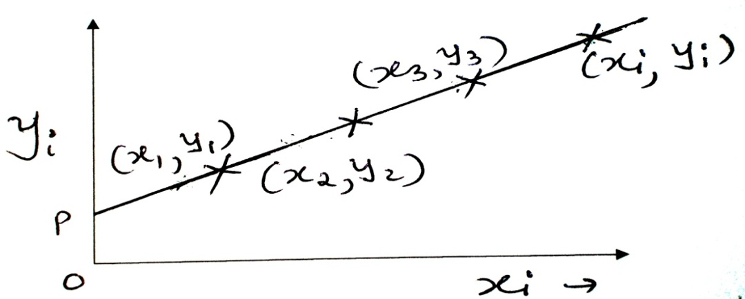

The general form of equation of a straight line is

y = m x + c **(1)**

Where c represents the intercept along y-axis and m is the slope of the line, respectively.

For a given pair of data (xi, yi), the best-fitted values of m and c are given by  **(2)** Where, deviation in individual measurement = di = x i -  **(3)**

=  and **(4)**

 **(5)**

**Method:**

Suppose there are n pairs of measurements in which the nature of the graph is linear. For example, in the experiment of a flywheel, angular acceleration for different ten values of the applied couple.Take yi **=** angular acceleration and xi = applied couple. Using equation (2) calculates the values of slope (m) and intercept on the y-axis ( c ), which are the moment of inertia and a frictional couple of the flywheel.

**Set-1**

**Observation Table:**

|  |  |  |  |  |  |
| --- | --- | --- | --- | --- | --- |
| Obs No. | xi | yi |  | di yi |  |
| 1 | 0.1 | 8675 |  |  |  |
| 2 | 0.2 | 9632 |  |  |  |
| 3 | 0.3 | 10589 |  |  |  |
| 4 | 0.4 | 11789 |  |  |  |
| 5 | 0.5 | 12589 |  |  |  |
| 6 | 0.6 | 13654 |  |  |  |
| 7 | 0.7 | 14563 |  |  |  |
| 8 | 0.8 | 15547 |  |  |  |
| 9 | 0.9 | 16987 |  |  |  |
| 10 | 1 | 18267 |  |  |  |
| n=10 |  |  |  |  |  |

**Calculations :**

**[1]**  =________

**[2]**  =________

**[3]**  =_______

**[4]**  =________

**Graphical Method**

**[1]** Slope =AB/BC =_________________ = ______________

**[2]** Intercept on Y-axis =

**Results-1:**

|  |  |  |
| --- | --- | --- |
| **Sr. No.** | **Using Computations** | **From Graph of yi →xi** |
| **Slope** |  |  |
| **Intercept on Y axis** |  |  |

**Set-2**

**Observation Table:**

|  |  |  |  |  |  |
| --- | --- | --- | --- | --- | --- |
| Obs No. | xi | yi |  | di yi |  |
| 1 | 0.1 | 7564 |  |  |  |
| 2 | 0.15 | 9435 |  |  |  |
| 3 | 0.2 | 10438 |  |  |  |
| 4 | 0.25 | 12627 |  |  |  |
| 5 | 0.3 | 14253 |  |  |  |
| 6 | 0.35 | 16620 |  |  |  |
| 7 | 0.4 | 18246 |  |  |  |
| 8 | 0.45 | 20357 |  |  |  |
| 9 | 0.5 | 22654 |  |  |  |
| 10 | 0.55 | 24357 |  |  |  |
| n=10 |  |  |  |  |  |

**Calculations :**

**[1]**  =________

**[2]**  =________

**[3]**  =_______

**[4]**  =________

**Graphical Method: Plot a graph of yi →xi and find out the slope and intercept on the y-axis.**

**[1]** Slope =AB/BC =_________________ = ______________

**[2]** Intercept on Y-axis =

**Results-2:**

|  |  |  |
| --- | --- | --- |
| **Sr. No.** | **Using Computations** | **From Graph of yi →xi** |
| **Slope** |  |  |
| **Intercept on Y axis** |  |  |

**Set-3**

**Observation Table:**

|  |  |  |  |  |  |
| --- | --- | --- | --- | --- | --- |
| Obs No. | xi | yi |  | di yi |  |
| 1 | 40 | 7564 |  |  |  |
| 2 | 60 | 9435 |  |  |  |
| 3 | 80 | 10438 |  |  |  |
| 4 | 100 | 12627 |  |  |  |
| 5 | 120 | 14253 |  |  |  |
| 6 | 140 | 16620 |  |  |  |
| 7 | 160 | 18246 |  |  |  |
| 8 | 180 | 20357 |  |  |  |
| 9 | 200 | 22654 |  |  |  |
| 10 | 220 | 24357 |  |  |  |
| n=10 |  |  |  |  |  |

**Calculations :**

**[1]**  =________

**[2]**  =________

**[3]**  =_______

**[4]**  =________

**Graphical Method**

**[1]** Slope =AB/BC =_________________ = ______________

**[2]** Intercept on Y-axis =

**Results-3:**

|  |  |  |
| --- | --- | --- |
| **Sr. No.** | **Using Computations** | **From Graph of yi →xi** |
| **Slope** |  |  |
| **Intercept on the Y axis** |  |  |

**VP & RPTP Science College, Vallabh Vidyanagar**

**BSc [Semester-I] Subject: Physics**

**Course Number: US01CPHY22**

**Viva-Voce**

**ELECTRONICS-General Questions**

**What is Electronics?**

The word ‘ELECTRONICS’ is derived from ELECTRON mechanICS.

“The electronics means the study of the behavior of an electron under different conditions of externally applied fields”.

**OR**

“The field of science and engineering which deals with electron devices and their utilization”.

**What are the applications of Electronics?**

The major fields of application of electronics are Communications and Entertainment, Defense ( Radar, Guided missiles, Coded communications), Industry (Automatic control system, Heating, and Welding, Computers), Medical (X-rays, EM), Instrumentation (precision measuring instruments, VTVM, CRO, pH meter).

**COMPONENTS OF ELECTRONIC CIRCUIT**

**What are the basic components of any electronic circuit?**

Electronic components

Passive Components Active components

Resistors Capacitors Inductors Tube devices Semiconductor devices

**Define Passive Components? Give examples.**

The components of the circuit, which are not capable of amplifying or processing electrical signals by themselves. e.g. Resistor, Inductor, Capacitor, etc.

**What are the active components in a circuit?**

The components of the circuit which can process or amplify the input signal are called active components.

**Give some examples of active components of the circuit?**

**Tube device such as** a Gas diode, Vacuum triode, Vacuum pentode, Vacuum diode

**A semiconductor device such as** PN junction diode, Zener diode, Transistor

**RESISTORS - PASSIVE COMPONENTS**

**Electrical Resistance:** The natural property of a substance that opposes the flow of current through it is called resistance. It is measured in ohm.

**Electrical resistivity:** A measure of materials' ability to oppose the flow of an electric current. The resistivity of materials is given by, where R is the resistance of uniform specimen of the materials having a length (l) and cross-sectional area (A). It is measured in ohm – meter.

**Electrical conductivity:** It is reciprocal of the electrical resistivity ().

**State Ohm’s law.**

The ratio of the potential difference between two ends of a conductor to the current flowing through it is constant. This constant is the resistance of the conductor. i. e.

.

Where V is the potential difference in Volt, I is the current in Ampere and R is the resistance in Ohm.

**One ohm:** If one ampere of current flow through a circuit at an applied e. m. f. of one volt, the resistance of the circuit is said to be one ohm.

**CAPACITOR - PASSIVE COMPONENT**

**Capacitor:** A capacitor is basically meant to store electrons (or electrical energy), and release whenever desire.

* It is a device in which a large amount of charge can be stored.
* It consists of two metal plates placed parallel to each other at a short distance. The intermediate space is filled with some dielectric.

**The capacity of a capacitor:** Capacitance of a capacitor is the ratio of electric charge on it to its electric potential due to that charge.

**One farad:** Capacitance of a capacitor is said to be 1 farad if one Coulomb of charge raises it’s potential through 1 volt. 

* Farad is a big unit. Smaller units generally used are:
* 1 micro-farad (μF) = 10-6 farad
* 1 micro-micro-farad (μμF) = 1 pF = 10-12 farad

**On what factors the capacity of a capacitor depends?**

It depends upon the following three factors 

**Area of the plate**, capacity increases with the increase of area.

**Distance between the plates**, capacity increases when the distance between the plates is decreased.

**The dielectric constant of the medium**, greater the value of the dielectric constant, greater the capacity.

**What is the function of the dielectric in the capacitor?**

* It increases the capacity of the capacitor.

**Dielectric constants of the materials:** The ratio of the capacitance with and without the dielectric between the plates is called the dielectric constant of the material used.

* **Which is the best dielectric and why?**
* **Mica** is the best dielectric because its value is high and the dielectric strength is several kilovolts per mm i. e. its insulation does not break even if the high potential difference is applied on its coating. It is used in all good standard capacitors.

**Types of capacitors:** The type of capacitor is usually denoted by the name of the dielectric used in the capacitor such as paper, mica, ceramic, electrolytic, air, oil, etc.

**INDUCTOR - PASSIVE COMPONENT**

**Inductors:** When current flow through a wire that has been coiled, it generates a magnetic field. This magnetic field reacts so as to oppose any change in current. This reaction of the magnetic field, trying to keep the current flowing at a steady rate, is known as 'inductance'. The device is called ‘inductor’.

**Self-induction.** For a medium with constant permeability, magnetic flux linked with the circuit is proportional to the current flowing through it. **,** L is self-inductance.

[]

Self-induction is defined as flux linked with coil when unit current flows through it.

**OR** 

Self-inductance is defined as emf induced in the circuit when the rate is of change of current is unity.

**What is the unit of self-inductance?** It is measured in henry.

**Define one henry.** The inductance of a coil is said to be 1 henry if emf of 1 volt is induced when the current in it changes at the rate of 1 ampere per second.

**ACTIVE COMPONENTS**

**SEMICONDUCTORS- SEMICONDUCTOR DIODE-ZENER DIODE**

**What is a semiconductor?** A semiconductor is a solid material whose electrical resistivity is higher than that of a conductor and lower than that of an insulator.

**Name at least two conductors, two insulators and two semiconductors?**

**Define intrinsic and extrinsic semiconductors?**

**Define doping.** It is the process of adding impurity (trivalent or pentavalent) to pure semiconductors in the desired quantity to alter its properties.

**Define N-type semiconductor (donor type semiconductor).**

An impurity semiconductor is said to be of donor type or N-type if the impurity has a valency of five.

**Define P-type semiconductor (accepter-type semiconductor).**

**Explain what is a hole?**

**Explain why the pentavalent impurity atom is known as donor-type impurity?**

**Explain why the trivalent impurity atom is known as acceptor-type impurity?**

**What is the PN Junction diode?**

**What is a forward-biased diode?**

**What is a reverse-biased diode?**

**What are the applications of the PN junction diode?**

Ans In a rectifier, detector circuits and switching circuits

**RECTIFIER- HALF- WAVE RECTIFIER AND FULL- WAVE RECTIFIER CIRCUITS**

**Define rectifier.** A rectifier is a circuit that converts AC into DC.

**Define AC.** An electrical current that reverses its direction with a constant frequency.

**Define DC.** An electrical current in which the net flow of charge is in one direction only.

**Define rectification.** Rectification is a conversion of AC into DC.

**Name the device or element that is used as a rectifier.**

**Define the half-wave rectifier.**

When a single diode is used as a rectifier, it rectifies only half cycle of an input AC signal. This is known as a half-wave rectifier.

**Define a full-wave rectifier.**

When a pair of a diode (or four diodes) is used as a rectifier, it rectifies both cycles of an input AC signal. This is known as a full-wave rectifier.

**Define the construction of a Full-wave Rectifier?** The full-wave rectifier is a circuit which rectifies both half cycles of the AC when P of 1st diode is positive; the 1st diode is forward biased and will conduct. Now the 2nd diode will not conduct as it is reverse biased. In all the half cycles either of the two diodes will be conducting. The efficiency of a full-wave rectifier is about 81.2 %, twice the efficiency of a half-wave rectifier.  
  
**What are the merits of the Full Wave Rectifier?**  
A major advantage of full-wave and bridge rectifiers over half-wave rectifiers is the ease of filtering their output voltages.

The ripple frequency is doubled; therefore, the time period the capacitor is allowed to discharge is cut in half. This means that the capacitor discharges less. Thus, ripple amplitude is less, and a smoother output voltage occurs.  
  
**What are the major disadvantages of the Full Wave Rectifier?**  
The only disadvantage is that the peak voltage in a full-wave rectifier is only half the peak voltage in a half-wave rectifier. This is because the secondary of the power transformer in a full-wave rectifier is center-tapped; therefore only half the source voltage goes to each diode.

**What is a filter circuit? Explain the importance of the filter circuit in the rectifier circuit.**

The output of the rectifier circuit is unidirectional but varies with time i. e. it is not a steady direct current. The filter circuit is used to obtain steady dc or to removes ripples from the output of a rectifier circuit.

**Give the name of the different filters.**

Shunt Capacitor Filter, Series Inductor Filter, LC Filter Circuit and  - Filter Circuit

**ZENER DIODE**

**What is a diode?** The diode is a device which has two electrodes.

**What is a Zener diode?**

A heavily doped P-N junction which has a sharp breakdown voltage is called as a Zener diode.

**On what factor does the breakdown voltage of a Zener diode depends?**

The breakdown voltage of a Zener diode depends upon the amount of doping. If the diode is heavily doped, the depletion layer will be thin and consequently, the breakdown of the junction will occur at a lower reverse voltage.

**What is the breakdown voltage?**

When the reverse bias on a Zener diode is increased, a critical voltage is reached at which the reverse current increases sharply to a high value. This critical voltage is called the breakdown voltage.

**What is the difference between an ordinary diode and a Zener diode?**

* A Zener diode is like an ordinary diode except that it is properly doped so as to have a sharp break down voltage.
* It has a sharp breakdown voltage called Zener voltage
* When forward biased, Zener diode characteristics are just that of an ordinary diode
* A Zener diode is always reverse biased.

**Why Zener diode is always reverse biased?**

Because it utilizes reverse characteristics for acting like a voltage regulator.

**Mention the uses of Zener diode.**

A Zener diode is used as a voltage regulator to provide a constant voltage from a source whose voltage varies over a sufficient range.

**What do you mean by voltage regulations?**

The variation in output of a rectifier with changes in load current is known as voltage regulations of the circuit. The voltage regulation is defined as the ratio of voltage at no load minus voltage at full load divided by the voltage at full load.

**Frequency of AC by Sonometer**

**What is meant by electric current?** The flow of electrons.

**What do you understand by AC OR DC?**

Alternating current (AC) changes its direction with a definite frequency. The direct current (DC) flows in one direction only.

**What is meant by frequency?** A number of vibrations per sec.

What do you understand by the frequency of A.C and what is its value?

**Does direct current also have any frequency? OR What is the frequency of AC in INDIA?** Ans. 50 cycles/s.

**If the tension (T or Mg) is increased by four times what will be the effect on the length of one loop?** Ans. The length of the loop (l) will increase by two times.

**What will happen if supply DC current? OR What is the frequency of DC?**

Ans. The rod will not vibrate because the soft iron piece will be magnetized in one direction only.

Ans. Zero.

**What is the principle, according to which the wire begins to vibrate when the alternating current is passed through it?**

**What is the function of the transformer here?**

**What is the function of the sonometer board? What is Sonometer?**

**What are the factors upon which the natural frequency of a sonometer wire depends?**

**Why do you use a step-down transformer?**

**Will be the frequency of the string be equal to the frequency of ac mains?**

**What kinds of vibrations are set up in the sonometer wire and air the air around?**

**Elasticity General Questions**

1. **Define elasticity.** It is a property of materials body to regain their original length, volume or shape after the deforming force has been removed.
2. **Define plasticity.**
3. **Define Stress.** The restoring force per unit area set up inside the body which is under the influence of deforming force.
4. **Define Strain.** The ratio of change in length (L), volume (V) or shape to the original length (L) volume (V) or shape.
5. What are the different types of stress and strain?
6. **State Hooke’s Law.** If the deforming force is not greater than the elastic limit, the strain is directly proportional to the stress. Stress α Strain **or** Stress = E Strain

Here constant ‘E’ is called “MODULUS OF ELASTICITY”.

1. **What is an elastic limit?** The maximum value of stress beyond which stress is not proportional to strain. (Beyond elastic limit strain is rapid).
2. **What are the units of (a) Stress and (b) Strain?**

Ans. (a) newton / meter2 or dyne / cm2

(b) No units since if the ratio between the similar quantities

1. **Gases and liquids have elasticity or not?** Yes, they have.

**‘Y’ BY CANTILEVER**

1. Define Young’s Modulus (Y).
2. Define cantilever.
3. What is the axis of bending and bending moment?
4. Which are the two methods to determine Y?
5. Which factors affect the final result of your experiment?
6. How will be the value of Y change with a change in *l*, *b* or *d* of the beam?
7. In this experiment which quantities should be measured accurately? Why?

**‘η’ by STATICAL METHOD**

1. Define the Modulus of Rigidity (η).
2. What are its units?
3. Is there any change in the angle of a twist if the diameter of the cylinder is changed?
4. How do you change η change with the change in the length and radius of the wire?
5. Which are two methods of determination of Modulus of Rigidity (η)?

**POISSON’S RATIO FOR RUBBER**

1. Define Poisson’s Ratio (σ).
2. Define lateral strain and linear strain.
3. State the limiting values of s?
4. Which factors affect the final result of your experiment?

**TORSIONAL PENDULUM**

1. What is a Torsional pendulum?
2. State two applications of this experiment.
3. Define periodic time. Ans. It is the time required to complete one vibration or oscillation. It is reciprocal of frequency and measured in seconds.
4. Which factors affect the final result of your experiment?
5. Define the Moment of Inertia and radius of gyration.
6. Which factors affect the Moment of Inertia?
7. Define Couple/torque.

**NUMERICAL - LEAST SQUARE FITTING METHOD**

1. Explain the basic principle of this experiment.
2. Why this method of computation is called as least square fitting method?
3. Define error. What is the significance of error in science?
4. What is an equation of a straight line?
5. Explain the importance of the least-squares fit method for linear dependence data?
6. What's the reason for wanting to do a least-squares fit?
7. Why we find the best fit line to a given set of data? Can this method be useful for non-linear data?
8. Give anyone example of an equation that may appear non- linear but can be made linear.

**General Questions**

**Define the least square fitting method.**

A statistical technique to determine the line of best fit for a model. The least-squares method is specified by an equation with certain parameters to observed data. This method is extensively used in regression analysis and estimation.

**Why this method is named as least-square fit?**

In the most common application - linear or ordinary least squares - a straight line is sought to be fitted through a number of points to minimize the sum of the squares of the distances (hence the name "least squares") from the points to this line of best fit.

The method of least squares requires that the vertical distance from each observed data point to the model line be such that the sum of the squares of these distances is a minimum.

**Who proposed this method first?**

The earliest description of the least-squares method was by Carl Freidrich Gauss in 1795.

**What is the importance of this method?**

* A line of best fit is a straight line that is the best approximation of the given set of data. It is used to study the nature of the relation between two variables. A line of best fit can be roughly determined by drawing a straight line on a [scatter plot](http://hotmath.com/hotmath_help/topics/scatter-plots.html) so that the number of points above the line and below the line is about equal (and the line passes through as many points as possible). A more accurate way of finding the line of best fit is the least square method.
* In many statistical investigations, the main goal is to establish relationships which make it possible to predict the value of one variable in terms of another. It would be ideal if we could predict one quantity exactly in terms of another, but this is seldom possible. We must be satisfied with predicting averages or expected values. Thus the problem of predicting leads to what is called the **problem of regression**.

**What is CURVE FITTING?**

Whenever possible, we try to express, or approximate, relationships between observed quantities and quantities that are to be predicted in terms of mathematical equations. Whenever a mathematical equation has been determined, the procedure is known as **curve fitting**.

=========================================================